

Department of Psychology

1835 Neil Avenue
Columbus, OH 43210

June 14, 2018

Dr. Randi Martin
Rice University
P.O. Box 1892
Houston, Texas 77251

Dear Dr. Martin, Dr. Tsakiris, and Dr. Wagemans:

The submitted manuscript entitled Attentional mechanisms drive systematic exploration in young children presents research examining the development of exploratory decision-making. Recent research indicates that young children’s choices may be highly exploratory, and furthermore largely systematic—despite immature prefrontal cortex, which converging evidence indicates plays a major role in systematic exploration in adults. We hypothesize that children’s systematic exploration is instead tied to different mechanisms, in particular their immature attention allocation pattern. We examine the connection between attention and children’s systematic exploration by manipulating salience within a simple reward learning task. Computational modeling analyses reveal that bottom-up capture of attention, through large differences in salience of choice options, greatly decreases the level of systematic exploration children exhibit. In addition, children’s choices did not indicate simple salience-seeking, but an interaction between reward and salience. These results deepen our understanding of the development of exploratory behavior and point to an integral role of attentional mechanisms in systematic exploration in young children—and furthermore, suggest that children’s immature attention may in fact be adaptive, facilitating broad information gathering. We believe that the manuscript should be of interest for the broad readership of Cognition.

The following individuals could be potential reviewers for this manuscript.
- Professor Linda Smith of Indiana University (smith4@indiana.edu)
- Professor Haley Vlach of University of Wisconsin-Madison (hvlach@wisc.edu)
- Professor Nora Newcombe of Temple University (newcombe@temple.edu)
- Professor Catherine Sandhofer of UCLA (sandhof@psych.ucla.edu)
- Professor Yuko Munakata of the University of Colorado-Boulder (munakata@Colorado.edu)

I hope that you will find the manuscript of sufficient interest and technical merit to be published in Cognition, and I look forward to hearing from you. Please address your correspondence concerning the manuscript to Nathaniel J. Blanco (nathanblanco@gmail.com).

Sincerely,
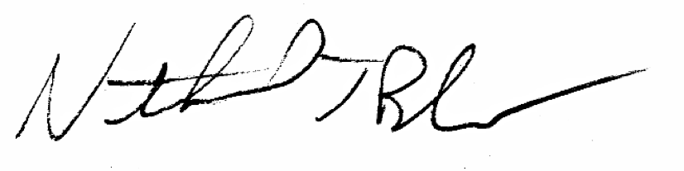
Nathaniel J. Blanco
The Ohio State University

